**Locality Sensitive Hashing(LSH) in C++**

**Introduction**

LSH is an algorithm for solving the aproximate or exact Near Neighbor Search in high dimensional spaces.

It finds:

* The nearest neighbor of a given point q
* The neighbors of q in a range with radius R

**Support**

The LSH algorithm supports:

* Euclidean Vector Space
* Cosine Vector Space
* Hamming Metric Space
* Distance Matrix Metric Space

**Compile**

Use **make** command to compile and **make clean** to delete object files(there is a **MakeFile**).

**Run**

./lsh –d <input file> –q <query file> –k <int> -L <int> -ο <outputfile>

-d <input file>: The input file name

Format of file:

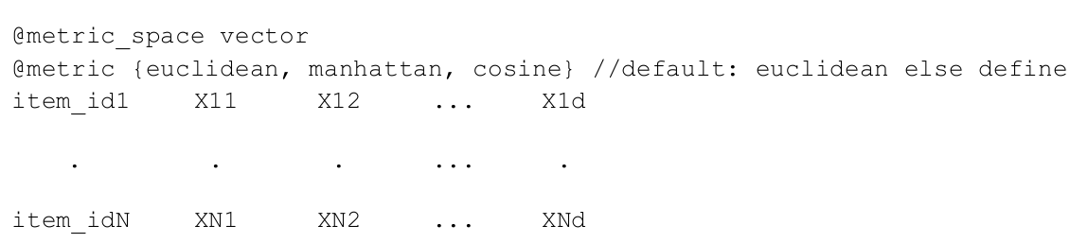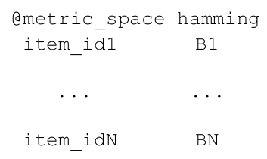

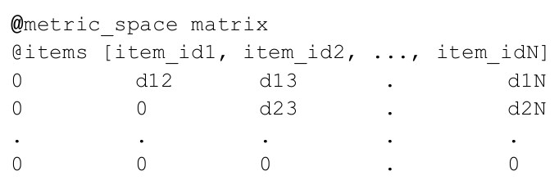

–q <query file>: query file name, format is

Euclidean, Cosine, Distance Matrix

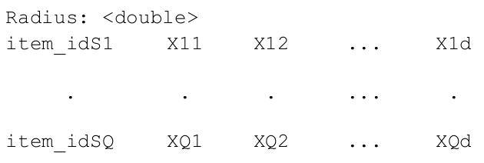

-ο <output file>: Output file name

-k <int>: The number of hi for the hashfunctions (the number of buckets in hashtables 2^k), default value 4

-L <int>: The number of hashTables in Lsh, default value 5.